# Wireless Power for Noise-Sensitive Circuits

The main idea of this project is to provide a safty to noise sensitive circuits.Generally we cannot say that weather noise is good or bad.Noise is bad for a circuits only it is having problrmatic relations to the requirements of system .For example in high precision analog circuits like 50 mV of noise coupling into a sensor signal could be dangerous ,but similer noise wouldn’t affect the purely digital circuit.

The hardwere and softwere component required for this project are

1.SLSTK2000A EFM8 evaluation board.

2.Simplycity Studio integrated development environment .

3.Scilab.

4.IDT P9038-R-EVK and P9038AC-R-EVK evaluation board .

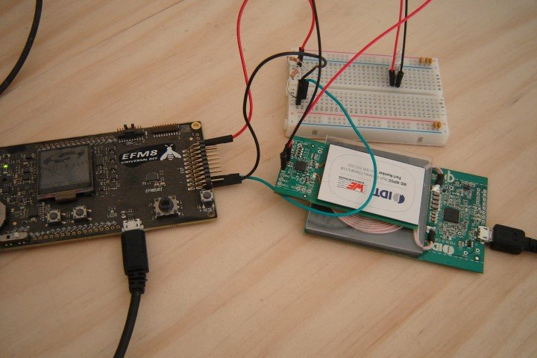

Link:https://www.allaboutcircuits.com/projects/wireless-power-for-noise-sensitive-circuits/